To: Church Centre Manager
2025
For Office use only
Booking Ref:
St Andrews Church
Kimbolton Road Tel: 01234 216881
Bedford
MK40 2PF email: bookings@standrewsbedford.org
Registered Charity no 1130171
Request to Hire St Andrew’s Centre Facilities
Please tick

Subject to the Conditions of Hire, a copy of which I have received and read

Please note: a booking cannot be confirmed until a booking form has been received.

Booking Details |  | Invoice Details (If different)
Contact Name: |  | Contact Name:
Organisation: |  | Organisation:
Address: |  | Address:
Phone: |  | Phone:
E-mail: |  | E-mail:

Requirements
Room |  |  | Resources |  | Refreshments |  | No of People
Church |  |  | Screen |  | Teas/Coffees
Main Hall |  |  | PowerPoint Projector |  | Biscuits
Holt |  |  | Flip Stand & Paper |  | Water & tumblers
Hulbert |  |  | Large TV
Dent |  |  | Sound System |  | Kettle & Crockery only
Consulting Room |  |  | Organ
Kitchen |  |  | Piano
Layout:
Tables |  |  | Contribution to  Performing licence
Chairs |  |  | Contribution to  Performing licence
 | Boardroom |  |  |  | External Caterers
 | Classroom |  |  |  | Name
 | Theatre |  |  |  | Phone
 | Horseshoe |  |  |  | Service
 | Circle |  |  |  | Time
 | Other |  | Detail – Please identify in Additional Information

Booking Dates
Date | Time of Hire  (Beginning & end) | Time meeting starts | No of People | Purpose/  Title of Meeting

For Regular Bookings, please circle required dates below
(Please note - we do not hire out rooms on Sundays or Bank Holidays)

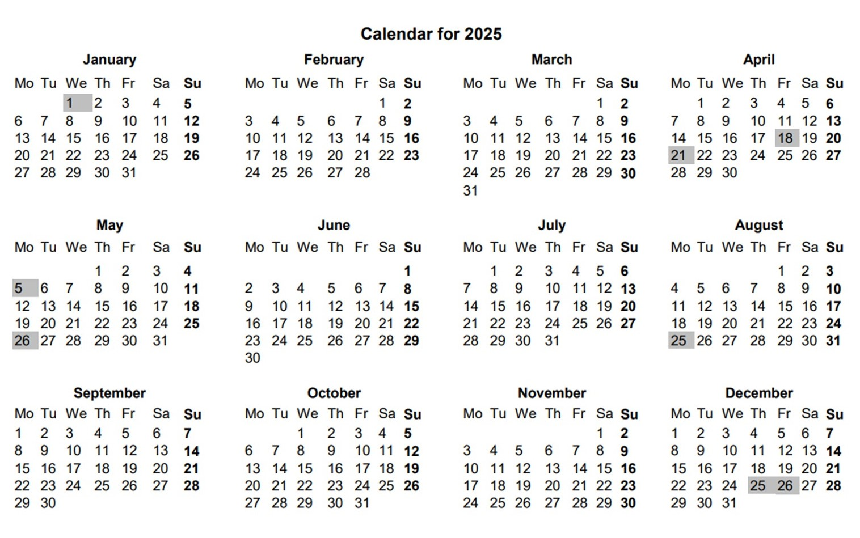

Additional Information / Comments

Organisation Type
Commercial Organisations / One-off Users |  | Community Groups
Church Members / Charities
Registered Charity Name & Number

I confirm that I have read and accept the Conditions of Hire sent to me, and that I have my own liability insurance to cover any claims that may be made by third parties.

Signature |  | Date

Signature |  | Date

The Management Accept no liability for loss or damage of any items left in the Centre

Notes:
- Timings: Please ensure there is adequate time before and after your meeting to allow for set-up and take-down.
- Cancellations: All bookings cancelled within one week of booking date will be subject to a 100% charge. All bookings cancelled within two weeks of booking date will be subject to 50% charge. All bookings cancelled with at least two weeks notice will not be subject to charge.
- Church Bookings: If the Centre is required for Church use this will take precedence over other bookings. In the event that the Centre is required every effort will be made to notify Hirers well in advance.

